**Global climate influenced the evolutionary history of brain size increase in some mammalian lineages, but not in hominins**

Brian M. Schilder1, W. Andrew Barr1, René Bobe2,3, Chet C. Sherwood1

*1Department of Anthropology, Center for Advanced Study of Human Paleobiology,*

*The George Washington University, USA*

*2Departamento de Antropología, Universidad de Chile, Santiago, Chile*

*3Institute of Cognitive & Evolutionary Anthropology, University of Oxford, UK*

*E-mail address*: [schilder@gwu.edu](mailto:schilder@gwmail.gwu.edu)

*Mailing address*: Science and Engineering Hall, 800 22nd St NW, Washington, DC 20052, USA

*Telephone*: 1-202-994-5923 (Lab)

*Key Words*: Variability selection, brain evolution, paleoclimate, isotopes, temporal autocorrelation

**ABSTRACT**

Increases in brain size over the course of evolutionary time have been observed in multiple mammalian lineages, including hominins. This has inspired a variety of competing proposals to explain the underlying forces driving brain size increase, among them large-scale changes in climate. However different aspects of the climate (e.g. trend, variability, and rate of change in temperature and/or aridity) have been promoted as alternate scenarios of global climatic influences on hominin evolution, without addressing the possibility that these highly interrelated climatic variables could simultaneously be contributing factors. Furthermore, previous investigations of this topic have not appropriately accounted for temporal autocorrelation by detrending time series data, risking the possibility of finding false positive relationships between brain size and climate. Here we investigated the relationship between different measures of the global oxygen isotope record (trend, variability, and rate of change) and cranial capacity (CC) using a dataset of 227 fossil species representing five different mammalian taxon and 298 ancestral CCs reconstructed based on data from extant taxa. While CC was correlated with some aspects of global climate in particular lineages, hominin brain size was shown to be unrelated to climatic forces. This study does not support previous assertions that climatic shifts drove hominin brain evolution and describes statistical methods that can guard against false positive relationships to which time series data are highly susceptible.

200 word limit!

**INTRODUCTION**

Since the divergence of hominins from the genus *Pan* ~5-7 Ma, our lineage has undergone a massive expansion in brain size, such that modern humans have brains that are over three times larger than those of the other great apes*,* our closest extant relatives (Schwartz and Tattersall, 2004; Holloway, 2008; Sherwood et al., 2008; Klein, 2009; Shultz et al., 2012a). However this phenomenon is not unique to our lineage, as evolutionary increases in brain size have also been demonstrated in Primates, Carnivora, Artiodactyla and birds (Lefebvre et al., 2004; Shultz and Dunbar, 2010).

While the precise causes of evolutionary brain enlargement remain unclear, many hypotheses revolve around enhanced cognitive flexibility (Lefebvre et al., 2004; Sol et al., 2005; Krubitzer, 2009; Sol, 2009). Organisms may evolve larger brain size as an adaptation to more efficiently solve novel problems and thus flexibly respond to changes in their dietary niche (Broadhurst et al., 1998; Carmody and Wrangham, 2010) or the navigation of complex social networks (Dunbar, 1998; Shultz and Dunbar, 2007; 2010). Large-scale changes in climate have also been proposed as a cause of brain evolution. However, which aspects of climatic change are the actual driving forces is a matter on ongoing debate, particularly in the field of human origins (Behrensmeyer, 2006; Potts, 2013). Trend-based hypotheses implicate long-term directional changes in aspects of the climate, such as temperature and/or aridity as the primary drivers of evolution (e.g. savannah hypothesis, aridity hypothesis, and aspects of turnover pulse hypothesis) (Vrba et al., 1994; deMenocal, 2004; Domínguez-Rodrigo, 2014). Alternatively, variability-based hypotheses implicate increasingly severe climatic fluctuations (e.g. variability selection hypothesis, variability pulse hypothesis) (Potts, 1996; 1998a; Bobe et al., 2002; Trauth et al., 2007; 2010; Maslin et al., 2014; 2015). More specifically, variability-based hypotheses posit that increases in the amplitude and periodicity of global environmental fluctuations may influence some species to become more versatile and thus to more effectively adapt to rapidly changing environments. In this scenario, hominins responded to this increased demand for versatility by evolving larger brains capable of enhanced behavioral plasticity (Potts, 2012). Lastly, some have suggested the rapidity at which climate change occurs may be a driver of evolution, here referred to as rate-based hypotheses (e.g. turnover pulse hypothesis) (Vrba, 1993; 1995; 1996).

While often conceptualized as mutually exclusive, there is in fact considerable overlap between these hypotheses. Changes in trend, variability, and rate are highly interactive aspects of the global climate that can in turn have complex downstream effects on environment at the level of continents, regions, local habitats, and communities of organisms (Zachos et al., 2001; Maslin and Christensen, 2007). Therefore it seems more appropriate to test these hypotheses within a single comprehensive model.

While there have been numerous claims of a relationship between hominin brain size and climate (Vrba et al., 1994; Vrba, 1995; 1996; Potts, 1998b; 2012; Shultz and Maslin, 2013; Maslin et al., 2015) very few studies have attempted to statistically test this relationship. Ash & Gallup (2007) examined the relationship between brain evolution and climate, finding that both global cooling trends and global temperature variability significantly correlated with increasing hominin CC (n=109 specimens) over the last 2 Ma. In a subsequent multivariate analysis of the Ash & Gallup (2007) dataset, Bailey & Geary (2009) found that climatic trends towards global cooling and increased variability as well as other predictors of CC (e.g. estimated population density, parasitic load) predicted hominin CC. Despite these efforts, the conclusions that can be drawn from these studies have some notable limitations. First, no study to date has included a sample of other mammalian taxa to determine whether climate variables are related to brain size variation as a general principle of mammalian evolution outside of hominins. The paleontological record demonstrates that brain size has increased across many different taxa (Jerison, 1973; Montgomery et al., 2010; Boddy et al., 2012) but it remains to be determined whether these increases relate to climatic shifts. Second, previous studies have not included measures of the rate or speed of climatic change as factors that might also be associated brain evolution. Lastly, and perhaps most importantly, the confounding effects of temporal autocorrelation in time-series data (such as brain size change over time vs. climatic change over time) have not been accounted for in any prior investigations. TAKE IT TO THE BRIDGE

The use of time series data is common in many fields, including ecology. Temporal autocorrelation, or the tendency of a data to correlate with itself over points in time may result in non-stationary (trended) time-series dataset (Chatfield, 2013). This can lead to spurious cross-correlations between two time-series that are in fact not causally related. Just one of numerous examples of this error is the relationship between the westward tectonic movement of North America and the global isotope record (Alroy et al., 2000). Both data sets show directional change over time (i.e. are non-stationary) and thus show strong cross-correlations despite being causally unrelated to one another. This renders any interpretations of causality between trended time series as highly suspect, as temporal autocorrelation can often cause even random walks to produce significant cross-correlations. Alroy and colleagues (2000) discuss the pitfalls of failing to account for the effects of temporal auto-correlation in the context of relating oxygen isotope time series to biotic data (e.g. Cenozoic mammalian diversity and body mass over time). This clearly demonstrates the potential for spurious correlations (and thus unfounded conclusions) that can come about when correlating time-series data with directional trends. The authors note that while it is tempting to observe two strong trends over time and declare that they are causally related, it is far more informative to observe the “*blow-by-blow, interval-by-interval”* time points*.*

The first goal of the present study was to identify which mammalian taxa (if any) display evidence for evolutionary increases in brain size over time. This was assessed using two independent sources of CC data: fossil CCs and ancestral state reconstructions derived from extant mammalian CCs. The fossil record is limited in a number of ways, including the error associated with various dating techniques (Ludwig and Renne, 2000) and the possibility that the earliest representatives of phylogenetic lineages have not yet been discovered. The fragmentary nature of many fossils often make taxonomic placement of these specimens challenging or sometimes inconclusive. Furthermore, taphonomic processes can potentially deform the endocranial cavity of the skull, thus affecting the ultimate estimate of CC (Holloway, 2008). Thus uncertainties in dating and morphological estimates in the fossil record pose some notable sources of error.

We used ancestral state reconstruction as a complementary method to computationally infer the most probable state of a common ancestor shared between two or more species. While this method avoids some of the limitations of the fossil record, it possesses several of its own inherent sources of error and assumptions. Notably, it inherits errors associated with the estimation of molecular divergence dates and species relationships from the chosen phylogenetic tree. Despite this, in the way we employ it here ancestral state reconstruction has the advantage of being derived from precise estimates of CC as they are directly measured from an extant sample of mammalian specimens. Here we employ both fossil and ancestral CCs in our analyses under the supposition that concurrence of results between both methods increases confidence in results showing a relationship between CC and climate variables.

The second goal was to test for potential relationships between changes in CC and changes in global climate, using the deep-sea oxygen isotope record as a proxy. In order to address the possibility of multiple climatic factors simultaneously influencing brain evolution, we used multiple regression models with CC as the response variable and three different measures of climatic change as the predictor variables. Each climatic measure was intended to represent a different climatic hypothesis:

1) *Trend*: This measure represents directional change-based hypotheses (e.g. deMenocal’s (2004) aridity hypothesis ), which predict that trends towards colder temperatures and increased aridity correlate with increased CC in hominins. This was quantified as mean oxygen isotope values in a given time interval.

2) *Variability*: This measure represents variability-based hypotheses (e.g. Potts’ (1996; 1998a; 1998b; 2012; 2013) variability selection hypothesis) which predict that increased fluctuations in global temperature and aridity lead to increased CC in hominins. This was quantified as standard deviation of oxygen isotope values in a given time interval.

3) *Rate*: This measure draws from aspects in both trend- and variability-based hypotheses and predicts that increases in the rate of change in global temperature and aridity lead to increases in CC. This was quantified as the slope of the linear regression of oxygen isotope values in a given time interval.

The third goal of this study was to assess whether correcting for temporal autocorrelation has any effects on the relationship between CC and global climate.

Each taxon has its own evolutionary history, array of ecological niches, and distribution across habitats, which can influence how they respond to a given environmental pressure. Thus we predicted that each taxon may be differentially affected by various aspects of global climatic shifts over time (i.e. trend, variability, rate), if at all.

**MATERIALS AND METHODS**

***Fossil CC Data***

CCs for 227 mammalian fossil species from six different taxa (Artiodactyla (*n*=20 species), Carnivora (*n*=129), Cetacea (*n*=26), Perissodactyla (*n*=14), and non-hominin Primates (*n*=19)) were extracted from the Shultz & Dunbar supplementary dataset (2010). For the hominin sample, CC and date (in Ma) for 189 individual specimens were extracted from Shultz, Nelson, & Dunbar (2012a), Schoenemann (2013), and Berger et al. (2010). These individuals were fit into a scheme of 19 different hominin species including: *Ardipithecus ramidus* (n=1), *Australopithecus afarensis* (n=5), *Australopithecus africanus* (n=8), *Australopithecus garhi* (n=1), *Australopithecus sediba* (n=1), *Kenyanthropus platyops* (n=1), *Homo habilis* (n=10), *Homo rudolfensis* (n=3), *Homo ergaster* (n=6), *Homo georgicus* (*n*=3), *Homo erectus* (n=33), *Homo floresiensis* (n=1), *Homo antecessor* (n=3), *Homo heidelbergensis* (n=21), *Homo neanderthalensis* (n=27), *Homo sapiens* (n=58), and the robust australopiths *Paranthropus aethiopicus* (n=1), *Paranthropus boisei* (n=6), and *Paranthropus robustus* (n=3). Species averages were calculated when multiple specimens per species were available.

Each specimen was assigned an associated date (Ma) corresponding to the First Appearance Datum (FAD) of that fossil species as an approximation of its emergence. We assume that any error associated with these measures was equally distributed across all taxa (Shultz and Dunbar, 2010).

While a complete set of analyses investigating CC, body size, encephalization quotient (EQ) (Martin, 1981; 1984) and their interrelated dynamics would be worthwhile, reliable estimates of body mass in fossil taxa are relatively sparse. In the Shultz & Dunbar dataset (2010), fossil body mass was often estimated based on cranial orbit measurements. However recent evidence (Elliott et al., 2014) suggests that orbit dimensions are not reliable estimators of hominin body mass, as previously suggested (Aiello and Wood, 1994). This issue is further compounded when comparing specimens across multiple mammalian taxa with highly variable relationships between orbit dimensions and overall body size. Furthermore, some evidence suggests that total CC is the best predictor than EQ of measures of intelligence (Deaner et al., 2007) and the ability to adapt to novel environments (Deaner et al., 2007; Sol et al., 2008).

***Ancestral CC Data***

To provide an independent source of CC data, ancestral state reconstructions were calculated via REML estimation using the Analysis of Phylogenetics and Evolution (APE) package (Paradis et al., 2004) in R version 3.1.2 (Team, 2014). In our model, we used a Restricted Maximum Likelihood (REML) estimation method that assumes species diverge according to Brownian motion and takes into account branch length. Despite these assumptions, it has proven capable of reliably generating reconstructions of biological measurements (e.g. brain size) that can be cross-validated with the fossil record. Previous investigations have utilized this method to reconstruct the brain size of Primates (Montgomery et al., 2010; Boddy et al., 2012), Carnivora (Finarelli and Flynn, 2007), Cetacea (Montgomery et al., 2013) and other mammalian taxa (Boddy et al., 2012).

Extant CCs tip data for Artiodactlya (n=25), Carnivora (n=157), and Cetacea (n=32) were taken from the Shultz & Dunbar dataset (2010) while Primate data (n=76) were taken from the Boddy et al. dataset (2012). The authors acknowledge that Cetacea and Artiodactyla represent the monophyletic clade known as Cetartiodactyla. However for the purposes of this study the clade is subdivided due to their drastically different ecologies, which are likely to be differently affected by global climatic changes. Tree data were derived from the Bininda-Emonds et al. (2007) mammalian supertree. Polytomies were resolved by assigning a branch length of 0.1 Ma in these instances, which sufficiently differentiated a given shared node into several independent nodes while minimizing the effect of altering the branch lengths on the ancestral state reconstruction results. This alteration proved necessary, as branch lengths of 0 resulted in computational errors in the REML calculations. The REML produced 298 total ancestral CCs with the following distribution by taxon: Artiodactlya (n=24), Carnivora (n=156), Cetacea (n=31), Perissodactyla (n=8), Primates (n=75).

***Climatic Data***

The deep-sea oxygen isotope record serves as a proxy for mean ocean temperature, which tracks global temperature over long periods of time. A high-resolution oxygen-isotope (∂18O) record calibrated to the standard geomagnetic polarity time scale (GPTS) were extracted from the literature (Zachos et al., 2001). These data were originally culled from deep-sea core isotope records from 40 different sites around the world spanning from present day to 65Ma. Since isotopic values do not vary significantly by site, it is appropriate to use the combined dataset as a proxy for global climate change. This record provides a proxy for global temperature shifts that can in turn affect various regions through a network of complex environmental interactions.

Measures of mean, standard deviation (sd) and slope of the ∂18O record were calculated for a given span of time, referred to as intervals. All analyses were repeated separately for each interval: 1My, 400Ky, and 200Ky. For example, if a species appeared at 2Ma, that species’ CC would each be correlated with each climatic measure (i.e. mean, sd and slope) over the course of 2.0-3.0Ma (1My interval), 2.0-2.4Ma (400k interval), and 2.0-2.2Ma (200Ky interval). The 400Ky and 200Ky intervals correspond to periodic cycles of orbital (Figure X) (Potts, 1998a; Zachos et al., 2001). 1Ma intervals were also investigated in an attempt to capture a large number of climatic events per unit, which may be related gradual long-term evolutionary changes in certain taxa (Foley, 1994).

**Analyses of *CC vs. Time***

First, Ordinary Least Squares (OLS) linear regression were performed in R using the lm function in the stats package (Team, 2014). CC was used as the response variable while time (in terms of Ma) was used as the predictor variable, first with all taxa grouped together and then divided into five separate taxa to elucidate the relative contribution of each taxon to any potential overall mammalian patterns. These analyses were repeated separately for the fossil and ancestral reconstruction CC datasets.

***Analyses of CC vs. Climate***

Next, multiple regressions analyses were performed also using the lm function in R (Team, 2014). Again, CC was the response variable but the previously calculated climatic measures were used as predictor covariates (*CC ~ mean + sd + slope*). All analyses were conducted separately using the fossil CC and then ancestral reconstruction CC datasets (source code provided in SI).

There are several well-established methods that can statistically account for temporal auto-correlation (Chatfield, 2013). The goal of these methods is to convert the non-stationary (trended) time series into a stationary (detrended) time series, or a time series that does not show a directional trend over time. The effect of detrending a previous trended dataset is illustrated in Figure X. A commonly used method is to calculate the first differences of the original time series (Alroy et al., 2000). The corrected (detrended) time series are computed as the following: y′t=yt−yt−1, where yt and yt-1 are temporally adjacent data points (e.g. oxygen isotope values) from which a differenced data point (y′t) is calculated. Note that the detrended time series of first differences will be of length n−1 where n is the length of the original pre-detrended time series. Thus, in the new detrended time series each point reflects the difference between adjacent time bins (Figure X). The resulting detrended time series can thus be used in subsequent analyses with other detrended time series. By employing this methodology one can be much more confident that any observed cross-correlations are meaningful relationships and not merely misleading coincidences.

To account for temporal autocorrelation in our study, we used the aforementioned methodology to detrend both the CC data and the oxygen isotope data by calculating the magnitude of difference between any two adjacent data points in time (Alroy et al., 2000). However, in order to do this some of the data had to be averaged as some specimens shared the same points in time. For example, if fossil species A (with a CC of 400mL) and B (with a CC of 500mL) both appeared at 22.1Ma, their CCs would be averaged to get a CC of 450mL for time point 22.1Ma.

**RESULTS**

***CC vs. Time***

Using the fossil CC dataset, when all taxonomic taxa were analyzed as one group there was a small but significant trend of increasing CC as time approached the present (Adjusted R2 =0.177, coefficient estimate (ce)=-0.035, standard error (se)=0.007, p =0.000). When separated by taxon, most mammalian taxa showed evidence of increasing CC over time, including Artiodactyla (R2=0.404, ce=-0.084, se=0.023, p=0.002), Carnivora (R2=0.139, ce=-0.038, se=0.008, p=0.000), Perissodactyla (R2=0.337, ce=-0.038, se=0.014, p=0.017), and Primates (R2=0.297, ce=-0.057, se=0.019, p=0.009). Hominins were treated as their own separate group to allow for comparisons with other mammalian taxa. Hominin species displayed the most dramatic increase in CC over time (R2=0.846, ce=-0.415, se=0.049, p=0.000). Results are shown in table X and Figure X.

Using the ancestral reconstruction CC dataset, when all taxa were analyzed as one group, there was a small but significant decrease in CC over time (R2=0.085, ce=0.035, se=0.007, p=0.000). No individual mammalian taxa displayed evidence of change over time, except for Primates, which showed an increase in CC as time approached the present (R2=0.074, ce=-0.024, se=0.177, p=0.012). As mentioned above, it was not possible to include hominins in this type of analysis. Results are shown in Table X and Figure X.

***CC vs. Climate***

Analyses of non-detrended data of fossil CC from all taxa (n=222) showed that Trend (quantified as mean) was the only significant predictor of CC (ce=0.908-1.102, se=0.1430-0.146, p=0.000) whereas Variability (sd) and Rate (slope) were not. This held true at 1My, 400Ky, and 200Ky intervals (Table X). When divided into separate taxa, Carnivora CC was also predicted by Trend at all intervals (ce=0.679-0.739, se=0.191-0.208, p=0.001-0.002) (Table X). Cetacea CC was only predicted by Rate at the 1My time interval (ce=2.286, se=0.836, p=2.735). Artiodactyla, perissodactyla, and Primate CC were not predicted by any of the climatic factors at any time interval (p>0.05). Species-mean hominin CC was predicted only by Trend at the 400Ky (ce=0.328, se=0.122, p=0.025) and 200Ky (ce=0.361, se=0.105, p=0.007) intervals. In order to explore the effect of increased sample size on the results, these data were re-analyzed with the hominin CC dataset broken into individual specimens, thus increasing the sample size from 13 species to 91 individuals. This expanded sample of hominins yielded additional relationships with Trend at the 1My interval (ce=0.221, se=0.043, p=0.000) as well as Variability at the 1My (ce=0.157, se=0.040, p=0.000), 400Ky (ce=0.219, se=0.033, p=0.000), and 200Ky (ce=0.192, se=0.034, p=0.000) intervals and Rate at the 1My interval (ce=0.058, se=0.019, p=0.003). See Table X for complete results.

Results differed considerably after detrending the CC and climatic data sets. For all mammals grouped together, Trend was no longer significant at any of the intervals. Rather, Variability (ce=3.967, se=1.927, p=0.044) and Rate (ce=0.206, se=0.090, p=0.026) were significant predictors of CC, but only at the 200Ky interval. Artiodactyla CC was only predicted by Rate at the 200Ky interval (ce=0.0542, se=0.145, p=0.010), as was Carnivora CC (ce=0.221, se=0.087, p=0.015). Cetacea CC was only predicted by Rate at the 1My interval (ce=2.648, se=0.715, p=0.006). Perissodactyla CC was only predicted by Variability at the 200Ky interval (ce=9.793, se=3.473, p=0.037). Primate CC was predicted by Trend (ce=-4.042, se=1.328, p=0.019) and Variability (ce=0.797, se=0.238, p=0.012) but only at the 200Ky interval. Notably, in contrast with the non-detrended data, detrended hominin CC was not significantly predicted by any climatic variables at any time intervals (p>0.313). This held true for even the larger sample of individual hominin specimen CCs, which also displayed no significant relationships with climate once data was detrended (p>0.384). See Table X for complete results.

Next, we performed the analyses described above with ancestral reconstruction of CCs. First using the non-detrended data, it was found that when all mammals were grouped together none of the climatic factors predicted CC (p>0.05). At the taxon level, Artiodactyla, Cetacea, Perissodactyla and Primate CC were also not predicted by any climatic factors (p>0.05). However, Carnivora CC was predicted by Variability at all three intervals (ce=0.145-0.158, se=0.071-0.075, p=0.030-0.043) and by Rate at the 1My interval (ce=-0.178, se=0.074, p=0.017).

See Table X for complete results.

After detrending the data, ancestral reconstruction of CCs showed a very different pattern of relationships with the climate. For all mammals, Trend was a significant predictor of CC at all time intervals (ce=2.176-2.414, se=0.226-0.228, p=0.000) while Rate was significant only at the 1My time interval (ce=-0.249, se=0.101, p=0.015) and Variability was a significant predictor at the 200Ky interval (ce=0.265, se=0.125, p=0.036). Carnivora CC was only predicted by Rate at the 1My interval (ce=-0.283, se=0.085, p=0.001). Artiodactyla, Cetacea, Perissodactyla and Primate CC were not predicted by any climatic factors at any interval (p>0.05).

See Table X for complete results.

**DISCUSSION**

In the fossil dataset, it was found that across mammals in general, there was a trend towards increased brain size over time. Subdividing the sample by taxon revealed that most, but not all, mammalian lineages contributed to this overall pattern. This is consistent with previous demonstrations of increasing absolute or relative brain size over time in the fossil record of Artiodactyla (Jerison, 1970; 1973), Carnivora (Jerison, 1970; 1973; Finarelli and Flynn, 2007; 2009), Perissodactyla (Edinger, 1948; Jerison, 1970), Primates (Holloway, 1968; Jerison, 1973), and hominins (Shultz et al., 2012b; Schoenemann and Begun, 2013). Cetacea were the notable exception to this pattern of increasing brain size, as their average brain size has remained consistently large since their emergence. The contrast of our results with those of previous studies that reported directional increases in Cetacean brain (Marino et al., 2004; Boddy et al., 2012; Montgomery et al., 2013) likely stems from differences in samples and methodology. It should, however, be noted that different taxa of mammals occupy different, partially overlapping time periods over the last 65Ma. Some taxa have existed much longer than others and thus span a much larger portion of the oxygen isotope record. This means that some taxa would have experienced a wider range of selective pressures, some of which could influence evolutionary shifts, speciation events, and extinctions.

Hominins occupy a particularly short and recent period of time (the last ~5-7Ma). This is, of course, partly due to the fact that they represent a taxonomic tribe rather than an order like most of the other taxa investigated here. Despite having only existed during a relatively brief time, hominins have undergone remarkable evolutionary increases in brain size which may have been in response to greater selective pressures for cognitively-mediated adaptability and problem solving in novel environments (Sol et al., 2005; 2008). This rapid increase in brain mass drastically deviates from the allometrically predicted brain mass of a primate of modern human body size and likely relates to many enhanced cognitive capacities including tool manufacture, complex social cognition, and language (Deacon, 2000; Passingham, 2008; Sherwood et al., 2008; Stout and Chaminade, 2012).

The results using ancestral reconstructions of CCs showed a rather different pattern. Instead of an overall increase in CC over time, there was in fact an opposite pattern of decreasing CC over time. When this was investigated at the level of separate taxa, it was found that no taxon showed any significant change in CC over time except Primates, which showed a slight increase (*Fig x*). This seemingly paradoxical pattern is at least partially explained by the high rate of speciation in smaller-brained Carnivora (relative to other larger-bodied taxa) over the last ~20 Ma, (see *figure X*). Indeed, when Carnivora are removed from the total sample of mammals, the size effect of the negative trend is reduced, though still significant (ce= 0.024, se= 0.009, p=0.009). Another contributing factor to the discrepancy between the fossil and the ancestral CC results was that it was not possible to include hominins in the ancestral reconstruction analyses, as *Homo sapiens* are the sole extant representatives of the hominin lineage. The lack of a hominin ancestral CC sample further suppressed the more recent average CC when all taxa were grouped together. This is evidenced by the fact that the effect of increasing brain size over time was reduced (ce= -0.035, se= 0.007, p=0.000) when hominins are removed from the grouped fossil taxa analysis.

When comparing these separate analyses of fossil and ancestral CC, the evidence for brain size increase over time can be categorized into three ascending levels of confidence: (1) low confidence (neither methods show CC increase over time; warranting no analyses of climate predicting CC), (2) moderate confidence (one method shows CC increase over time; warranting further analyses climate predicting CC), and (3) high confidence (both methods show CC increase over time; strongly warranting further analyses of climate predicting CC) (Table X). Cetacea fall in the low confidence category as neither method displayed evidence of increasing Cetacean CC over time. Artiodactyla, Carnivora, and Perissodactyla all displayed moderate confidence levels, as the fossil method indicated increasing CC while the ancestral method did not. The Primate taxon was the only taxon to display a high confidence level with similar results using both methods. This is in line with several previous investigations using a variety of methods and datasets that show Primates have indeed increased brain size over the course of evolutionary time (Holloway, 1968; Jerison, 1973; Montgomery et al., 2010; Boddy et al., 2012; Smaers and Soligo, 2013).

The present study found that some, but not all, mammals have increased brain size over time. Before detrending the data, we found no evidence of Primate CC being related to global climatic factors. However, detrending the data revealed otherwise hidden relationships, demonstrating that climatic changes in Trend, Variability, and Rate all affected fossil CC to different degrees. The combined effect of all three of these climatic factors in 200Ky intervals explained 62.9% of the variance in fossil Primate CC over the course of their ~65Ma existence as an taxon. Interpretation of these results should be tempered by the fact that the ancestral CC analyses did not reveal significant relationships between CC and climate. This illustrates the importance of using multiple independent sources of data to establish levels of confidence in one’s interpretation of evolutionary history.

Based on the fossil record data, it appears that hominins continued the Primate-general trend of increasing brain size, albeit at a greatly accelerated pace in the last 5-7Ma. But unlike other Primates, the rapid brain expansion observed in hominins appears to have been decoupled from global climatic events occurring at the time. Our analyses consistently found that hominins displayed no relationship between CC and any global climatic factors at any intervals. This held true whether or not the data was detrended, as well as with both fossil and ancestral CC data sets. This does not appear to simply be the result of low statistical power due to a small sample size of hominin species (n=18) since even when using the dataset of individual specimens (n=189) there were no significant brain-climate relationships based on detrended time-series. Thus, these results do not support previous claims that hominin brain size was driven by global climatic events. The discrepancy between our results and those of these previous reports (Ash and Gallup, 2007; Bailey and Geary, 2009) could stem from one or more of the following sources: insufficient sample sizes, testing single climatic factors at a time, and use of non-detrended data. In this study we demonstrated that the latter of these three factors consistently and dramatically alters the pattern of results due to the confounding effects of temporal autocorrelation. This clearly illustrates the necessity of detrending time-series data before conducting cross-correlation analyses. That said, as only the global climate was tested, it remains possible that changes in regional or local environment, or within time intervals less than 100Ky, could be associated with changes in hominin CC.

**ACKNOWELDGEMENTS**

The authors would like to thank Bernard Wood, John Kingston and Andrew Du for their invaluable feedback and direction throughout this project.

**References**

Aiello, L.C., Wood, B.A., 1994. Cranial variables as predictors of hominine body mass. American journal of physical anthropology. 95, 409–426.

Alroy, J., Koch, P.L., Zachos, J.C., 2000. Global Climate Change and North American Mammalian Evolution. Paleobiology. 26, 259–288.

Ash, J., Gallup, G.G., Jr., 2007. Paleoclimatic Variation and Brain Expansion during Human Evolution. Human Nature. 18, 109–124.

Bailey, D.H., Geary, D.C., 2009. Hominid Brain Evolution. Human Nature. 20, 67–79.

Behrensmeyer, A.K., 2006. ATMOSPHERE: Climate Change and Human Evolution. Science. 311, 476–478.

Berger, L.R., de Ruiter, D.J., Churchill, S.E., Schmid, P., Carlson, K.J., Dirks, P.H.G.M., Kibii, J.M., 2010. Australopithecus sediba: a new species of Homo-like australopith from South Africa. Science. 328, 195–204.

Bininda-Emonds, O.R.P., Cardillo, M., Jones, K.E., MacPhee, R.D.E., Beck, R.M.D., Grenyer, R., Price, S.A., Vos, R.A., Gittleman, J.L., Purvis, A., 2007. The delayed rise of present-day mammals. Nature. 446, 507–512.

Bobe, R., Behrensmeyer, A.K., Chapman, R.E., 2002. Faunal change, environmental variability and late Pliocene hominin evolution. Journal of Human Evolution. 42, 475–497.

Boddy, A.M., McGowen, M.R., Sherwood, C.C., Grossman, L.I., Goodman, M., Wildman, D.E., 2012. Comparative analysis of encephalization in mammals reveals relaxed constraints on anthropoid primate and cetacean brain scaling. Journal of Evolutionary Biology. 25, 981–994.

Broadhurst, C.L., Cunnane, S.C., Crawford, M.A., 1998. Rift Valley lake fish and shellfish provided brain-specific nutrition for early Homo. The British journal of nutrition. 79, 3–21.

Carmody, R.N., Wrangham, R.W., 2010. Cooking and the Human Commitment to a High-quality Diet. Cold Spring Harbor Symposia on Quantitative Biology. 74, 427–434.

Chatfield, C., 2013. The Analysis of Time Series. CRC Press.

Deacon, T.W., 2000. Evolutionary perspectives on language and brain plasticity. Journal of communication disorders. 33, 273–90– quiz 290–1.

Deaner, R.O., Isler, K., Burkart, J., van Schaik, C., 2007. Overall Brain Size, and Not Encephalization Quotient, Best Predicts Cognitive Ability across Non-Human Primates. Brain, Behavior and Evolution. 70, 115–124.

deMenocal, P.B., 2004. African climate change and faunal evolution during the Pliocene–Pleistocene. Earth and Planetary Science Letters. 220, 3–24.

Domínguez-Rodrigo, M., 2014. Is the “Savanna Hypothesis” a Dead Concept for Explaining the Emergence of the Earliest Hominins? Current Anthropology. 55, 59–81.

Dunbar, R.I.M., 1998. The Social Brain Hypothesis. Evolutionary Anthropology. 6, 178–190.

Edinger, T., 1948. Evolution of the Horse Brain. Geological Society of America.

Elliott, M., Kurki, H., Weston, D.A., Collard, M., 2014. Estimating fossil hominin body mass from cranial variables: An assessment using CT data from modern humans of known body mass. American journal of physical anthropology. 154, 201–214.

Finarelli, J.A., Flynn, J.J., 2007. The evolution of encephalization in caniform carnivorans. Evolution. 61, 1758–1772.

Finarelli, J.A., Flynn, J.J., 2009. Brain-size evolution and sociality in Carnivora. PNAS. 106, 9345–9349.

Foley, R.A., 1994. Speciation, extinction and climatic change in hominid evolution. Journal of Human Evolution. 26, 275–289.

Holloway, R.L., 1968. The evolution of the primate brain: some aspects of quantitative relations. Brain Research. 7, 121–172.

Holloway, R.L., 2008. The Human Brain Evolving: A Personal Retrospective. Annual Review of Anthropology. 37, 1–19.

Jerison, H., 1973. Evolution of The Brain and Intelligence. Elsevier.

Jerison, H.J., 1970. Brain evolution: new light on old principles. Science. 170, 1224–1225.

Klein, R.G., 2009. The Human Career. University of Chicago Press.

Krubitzer, L., 2009. In search of a unifying theory of complex brain evolution. Annals of the New York Academy of Sciences. 1156, 44–67.

Lefebvre, L., Reader, S.M., Sol, D., 2004. Brains, innovations and evolution in birds and primates. Brain, Behavior and Evolution. 63, 233–246.

Ludwig, K.R., Renne, P.R., 2000. Geochronology on the paleoanthropological time scale. Evolutionary Anthropology: Issues, News, and Reviews. 9, 101–110.

Marino, L., McShea, D.W., Uhen, M.D., 2004. Origin and evolution of large brains in toothed whales. The Anatomical Record Part A Discoveries in Molecular Cellular and Evolutionary Biology. 281, 1247–1255.

Martin, R.D., 1981. Relative brain size and basal metabolic rate in terrestrial vertebrates. Nature. 293, 57–60.

Martin, R.D., 1984. Body size, brain size and feeding strategies. 73–103.

Maslin, M.A., Brierley, C.M., Milner, A.M., Shultz, S., Trauth, M.H., Wilson, K.E., 2014. Quaternary Science Reviews. Quaternary Science Reviews. 101, 1–17.

Maslin, M.A., Christensen, B., 2007. Tectonics, orbital forcing, global climate change, and human evolution in Africa: introduction to the African paleoclimate special volume. Journal of Human Evolution. 53, 443–464.

Maslin, M.A., Shultz, S., Trauth, M.H., 2015. A synthesis of the theories and concepts of early human evolution. Philosophical Transactions of the Royal Society B: Biological Sciences. 370.

Montgomery, S.H., Capellini, I., Barton, R.A., Mundy, N.I., 2010. Reconstructing the ups and downs of primate brain evolution: implications for adaptive hypotheses and Homo floresiensis. BMC Biology. 8, 9.

Montgomery, S.H., Geisler, J.H., McGowen, M.R., Fox, C., Marino, L., Gatesy, J., 2013. The evolutionary history of cetacean brain and body size. Evolution. 67, 3339–3353.

Paradis, E., Claude, J., Strimmer, K., 2004. APE: Analyses of Phylogenetics and Evolution in R language. Bioinformatics (Oxford, England). 20, 289–290.

Passingham, R.E., 2008. What is Special about the Human Brain? Oxford University Press, USA.

Potts, R., 1996. Evolution and climate variability. Science. 273, 922–923.

Potts, R., 1998a. Variability selection in hominid evolution. Evolutionary Anthropology: Issues, News, and Reviews. 7, 81–96.

Potts, R., 1998b. Environmental hypotheses of hominin evolution. American journal of physical anthropology. Suppl 27, 93–136.

Potts, R., 2012. Environmental and Behavioral Evidence Pertaining to the Evolution of Early Homo. Current Anthropology. 53, S299–S317.

Potts, R., 2013. Hominin evolution in settings of strong environmental variability. Quaternary Science Reviews. 73, 1–13.

Schoenemann, P.T., Begun, D.R., 2013. Hominid brain evolution. A Companion to Paleoanthropology. 136–164.

Schwartz, J.H., Tattersall, I., 2004. The Human Fossil Record, Brain Endocasts--The Paleoneurological Evidence. John Wiley & Sons.

Sherwood, C.C., Subiaul, F., Zawidzki, T.W., 2008. A natural history of the human mind: tracing evolutionary changes in brain and cognition. Journal of Anatomy. 212, 426–454.

Shultz, S., Dunbar, R.I.M., 2007. The evolution of the social brain: anthropoid primates contrast with other vertebrates. Proceedings of the Royal Society B: Biological Sciences. 274, 2429–2436.

Shultz, S., Dunbar, R.I.M., 2010. Encephalization is not a universal macroevolutionary phenomenon in mammals but is associated with sociality. PNAS. 107, 21582–21586.

Shultz, S., Maslin, M., 2013. Early Human Speciation, Brain Expansion and Dispersal Influenced by African Climate Pulses. PloS one. 8, e76750.

Shultz, S., Nelson, E., Dunbar, R.I.M., 2012a. Hominin cognitive evolution: identifying patterns and processes in the fossil and archaeological record. Philosophical Transactions of the Royal Society B: Biological Sciences. 367, 2130–2140.

Shultz, S., Nelson, E., Dunbar, R.I.M., 2012b. Hominin cognitive evolution: identifying patterns and processes in the fossil and archaeological record. Philosophical Transactions of the Royal Society B: Biological Sciences. 367, 2130–2140.

Smaers, J.B., Soligo, C., 2013. Brain reorganization, not relative brain size, primarily characterizes anthropoid brain evolution. Proceedings of the Royal Society B: Biological Sciences. 280, 20130269–20130269.

Sol, D., 2009. Revisiting the cognitive buffer hypothesis for the evolution of large brains. Biology Letters. 5, 130–133.

Sol, D., Bacher, S., Reader, S.M., Lefebvre, L., 2008. Brain size predicts the success of mammal species introduced into novel environments. The American naturalist. 172 Suppl 1, S63–71.

Sol, D., Duncan, R.P., Blackburn, T.M., Cassey, P., Lefebvre, L., 2005. Big brains, enhanced cognition, and response of birds to novel environments. Proceedings of the National Academy of Sciences. 102, 5460–5465.

Stout, D., Chaminade, T., 2012. Stone tools, language and the brain in human evolution. Philosophical Transactions of the Royal Society B: Biological Sciences. 367, 75–87.

Team, R.C., 2014. R: A language and environment for statistical computing. R Foundation for Statistical Computing, Vienna, Austria, 2012.

Trauth, M.H., Maslin, M.A., Deino, A.L., Junginger, A., Lesoloyia, M., Odada, E.O., Olago, D.O., Olaka, L.A., Strecker, M.R., Tiedemann, R., 2010. Human evolution in a variable environment: the amplifier lakes of Eastern Africa. Quaternary Science Reviews. 29, 2981–2988.

Trauth, M.H., Maslin, M.A., Deino, A.L., Strecker, M.R., Bergner, A.G.N., Dühnforth, M., 2007. High- and low-latitude forcing of Plio-Pleistocene East African climate and human evolution. Journal of Human Evolution. 53, 475–486.

Vrba, E.S., 1993. Turnover-pulses, the Red Queen, and related topics. American Journal of Science. 293, 418–452.

Vrba, E.S., 1995. The fossil record of African antelopes (Mammalia, Bovidae) in relation to human evolution and paleoclimate.

Vrba, E.S., 1996. Climate, heterochrony, and human evolution. Journal of Anthropological Research. 52, 1–28.

Vrba, E.S., Vaisnys, J.R., Gatesy, J.E., Desalle, R., Wei, K.-Y., 1994. Analysis of paedomorphosis using allometric characters: the example of Reduncini antelopes (Bovidae, Mammalia). Systematic Biology. 43, 92–116.

Zachos, J., Pagani, M., Sloan, L., Thomas, E., Billups, K., 2001. Trends, rhythms, and aberrations in global climate 65 Ma to present. Science. 292, 686–693.

**FIGURES**

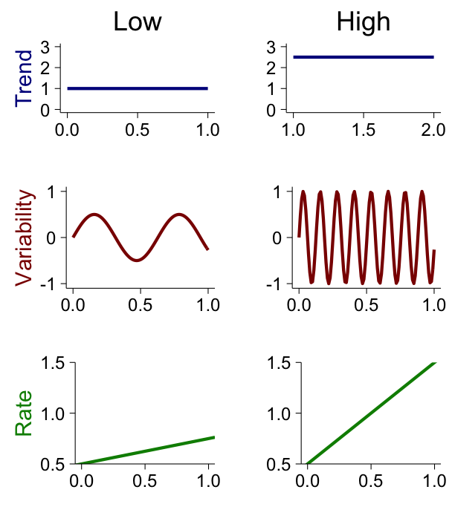

**Figure X**. A diagram displaying the interactive relationships between sources of

environmental variability.

**Figure X**. Cartoon illustration of examples of low vs. high Trend, Variability and Rate.

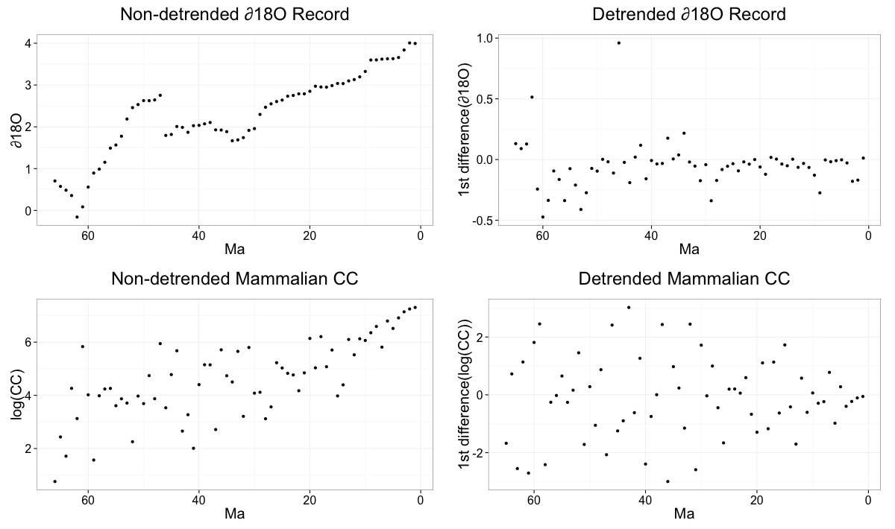**Figure X**. Demonstration of the effect of detrending time-series data (in this case the oxygen isotope record and mammalian CC over the last 65My) by calculating the first difference between temporally adjacent data points.

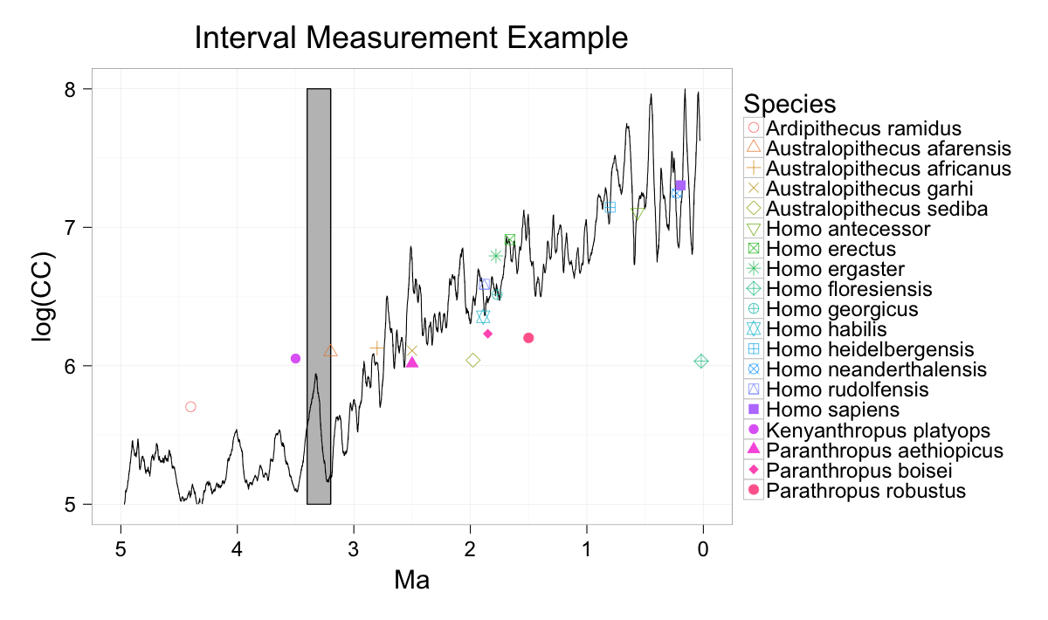

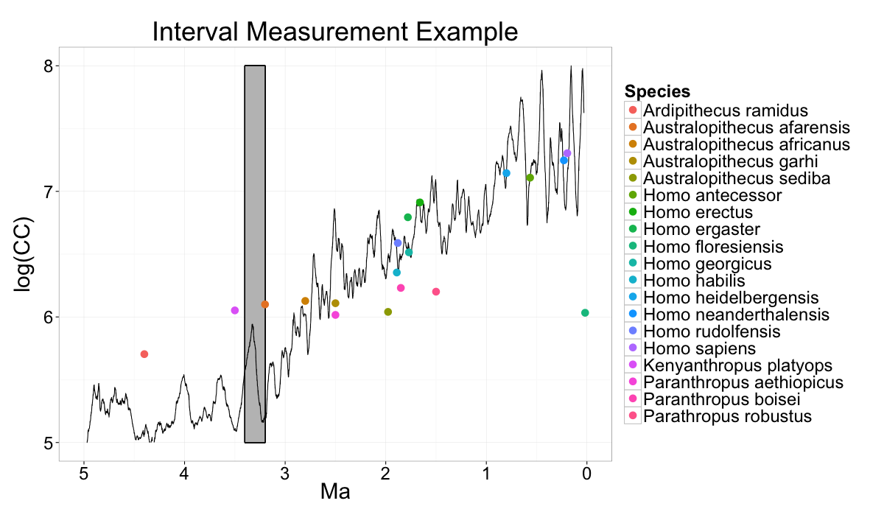

**Figure X**. Example of how measures of the oxygen isotope curve (black line) were collected from the time intervals preceding the FAD associated with a species (either fossil or ancestral). In this example, the 200Ky interval preceding the 3.2Ma date of Australopithecus afarensis is enclosed within the grey rectangle.

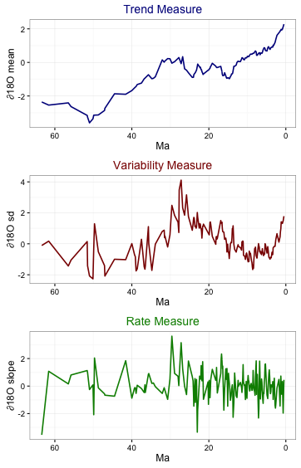

**Figure X**. Climatic measures (Trend, Variability, Rate) using 400Ky intervals of the oxygen isotope record over the last 65My.

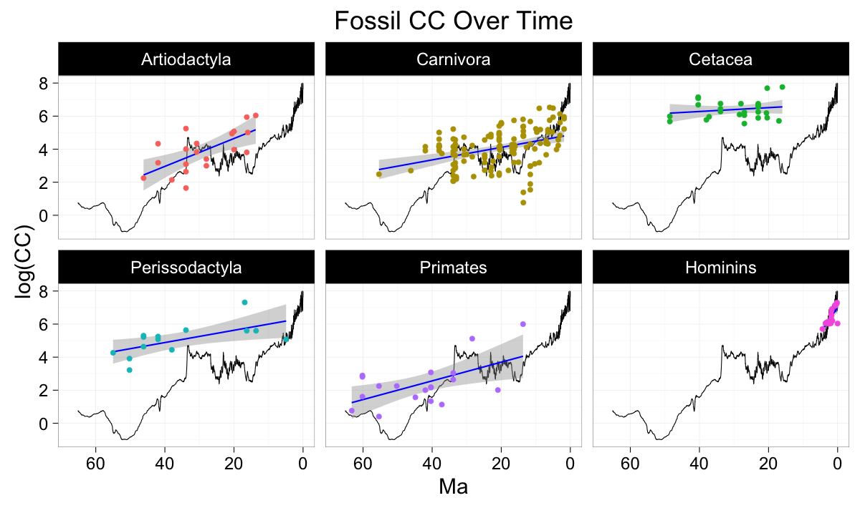

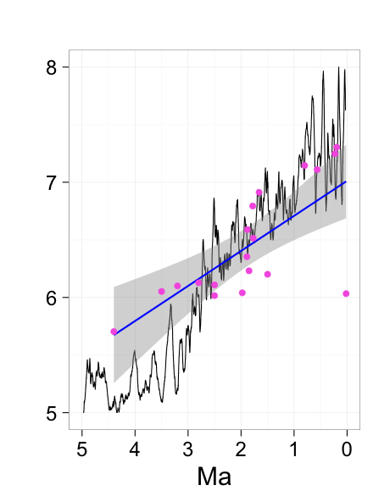

**Figure X**. Alternative visualization of fossil CC over time, with OLS regression line of CC (blue) and ∂18O curve (black), split into respective taxon.

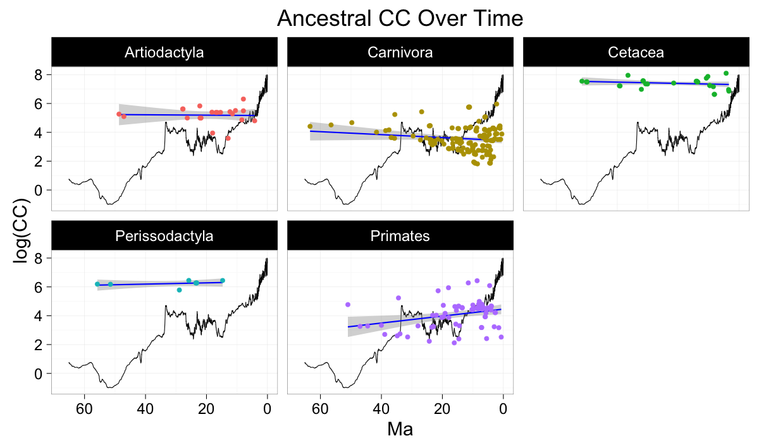

**Figure X**. Ancestral CC over time (points) with corresponding best fit lines from OLS regressions (blue) as well the ∂18O curve (black), subdivided by taxa.



**Table X**. Summary of significant/non-significant results from analyses of CC vs. climatic variable (Trend, Variability, Rate) using either non-detrended or detrended fossil or ancestral CC datasets. In the Significance columns, a value of “Y” denotes that the multiple regression analysis revealed a significant relationship between CC and the given climatic variable within a given taxon (e.g. All Taxa, Artiodactyla, Carnivora, etc.) within a given interval (e.g. 1My, 400Ky, 200Ky), whereas “N” denotes a lack of significant relationship (at p<0.05). In the Concordance columns, “1” denotes that analyses using both the fossil and the ancestral CC yielded similar results (either both “Y or both “N”), whereas “0” denotes that there was a discrepancy between the results of these datasets. In the Results Summary column, overall Concordance was calculated by taking the number of concordant values (“1”) and dividing over the total number of analyses (“1” or “0”) within a given taxon within a given interval. Evidence scores were calculated by taking the number of Detrended analyses that yielded a significant relationship between CC and a given climatic variable (“Y”) and dividing by the total number of analyses (“Y” or “N”) within a given taxon. Evidence scores did not include Non-detrended results due to the potential effects of temporal autocorrelation discussed in this paper.

**SUPPLEMENTARY MATERIALS**



**Table X**. Results of linear regressions in which fossil CC was the response variable and time (Ma) was the predictor variable. Negative estimate values mean that CC grew larger as we come closer to the present (Increase), positive estimate values mean CC grew smaller as we approach the present, and no significant means that there was no significant trend of CC in either direction (Stable).



**Table X**. Results of linear regressions in which ancestral reconstructed CC was the response variable and time (Ma) was the predictor variable. Negative estimate values mean that CC grew larger as we come closer to the present (Increase), positive estimate values mean CC grew smaller as we approach the present, and no significant means that there was no significant trend of CC in either direction (Stable).





**Table X.** Results of multiple regression analyses in which detrended fossil CC was the response variable and climatic measures (mean, SD, and slope of the ∂18O curve) were the predictor variables. Analyses were first conducted with all taxa grouped together, and then divided into respective taxa. Hominins were also subdivided into individuals (“Individualized Hominins”). Highlighted p values are significant at <0.05.

**Table X.** Results of multiple regression analyses in which non-detrended ancestral CC was the response variable and climatic measures (mean, SD, and slope of the oxygen isotope curve) were the predictor variables. Analyses were first conducted with all taxa grouped together, and then divided into respective taxa. Highlighted p values are significant at <0.05.

**Table X.** Results of multiple regression analyses in which detrended ancestral CC was the response variable and climatic measures (mean, SD, and slope of the oxygen isotope curve) were the predictor variables. Analyses were first conducted with all taxa grouped together, and then divided into respective taxa. Highlighted p values are significant at <0.05.